“Four or Five Acres of Irrigated Land”
Pima-Maricopa Irrigation Project Education Initiative

Restoring water to ensure the
continuity of the Akimel O’otham
and Pee Posh tradition of agriculture

Re

Part 19

Even if the Code-Newell-Hill scheme had been successful, the amount of land they proposed to irrigate with well water—10,000 acres—was too few to meet the needs of the Pima. Newell admitted this in 1905 but expressed his opinion that Pima farmers needed only an “average of 4 or 5 acres of good irrigated land.” That, Newell stressed, “is as much as the Indians need for the support of a family on land of that character and in that climate.” At the same time, non-Indians could acquire 160 acres of land under the Homestead Act or 640 acres under the Desert Land Act.
Newell also acknowledged that the small Indian acreage was designed to keep the costs of irrigation down to a minimum. “It will not be,” the Director of the Reclamation Service told a Senate Subcommittee, “a very expensive matter to provide such tracts with facilities for water.” It would simply require the development of wells near Santan and the removal of the Pima to “land around the wells.” The real costs, of course, were to be paid by the Pima through the sale of nearly half their reservation. This seems to be the primary motivating factor behind Newell’s proposal.
A year earlier, Newell submitted to Charles Walcott, Director of the US Geological Survey, a new report entitled The Underground Waters of Gila Valley, Arizona. The purpose of the report, written by Willis T. Lee, was to determine “the amount of water available for pumping, for irrigation by the [Pima] Indians.” The primary purpose, however, seems to be to support Code’s plan for pumping the underground waters of the Gila River for the benefit of the Pima.
Lee reported that many Indian wells still existed east of Sacaton with “the water ris[ing] in the wells practically to the level of the river bed.” Several non-Indian wells east of Blackwater were 25 feet deep. Two of A.J. Chandler’s wells in the Salt River Valley were 266’ deep and drew 2,275 gallons per minute. But by 1900 the water table was already impacted, with wells in Florence having to increase in depth from 40 to nearly 75 feet.
With groundwater pumping in its infancy, many of the swamps and sloughs along the Gila River still remained. On both sides of the river east of Sacaton were “swamps and sloughs containing water throughout the year.” These wetlands were in the area around the Blackwater shon, or spring. On the north bank of the river, a recently constructed canal drawing seepage from the river had already begun to impact the wetlands. “The ground near the ditch was soon drained,” Lee noted. Nonetheless, in 1903, water was still found from one to eleven feet below the surface. This underground flow of water maintained the shon and wetlands in the Blackwater area and sustained the native stands of Cottonwood, willow and mesquite that grew along the river. Wells in Sacaton that drew 450 gallons per minute in 1896, had been reduced to 250 gallons by 1903.
Further west in Gila Crossing there were six Indian ditches drawing seepage water from the Gila River. Five miles west of Pima Butte “the Lake” still existed. This lake was actually a swampy marsh north of the river west of Snaketown. The water extended in an east-west direction for nearly a mile and was at least six feet deep. A constant discharge of water from the lake into the slough fed the Gila River and kept the Pima-Maricopa canals on the west end of the reservation fed with water. Water was ubiquitous on the western third of the reservation and bogs and sloughs were of “frequent occurrence.” Large springs near Gila Crossing “boil[ed] up from the sand below” the river and supplied water in even the driest years.
The lake was important to the Pima and Maricopa, as well as to the wildlife that inhabited the area. The perpetual water supply in the lake and sloughs in the western part of the reservation survived not from a surface flow of the river but from the underground flow of water that traveled below the reservation. In 1903, the river no longer flowed across the east end of the reservation and for 50 miles upstream of the lake. Since there was not enough rain to supply the underflow, the Reclamation Service concluded the water came from an outside source. This source was the Gila River itself and the waters flowing through the washes that fed the Gila from the south and east. The Santa Cruz River also contributed a large volume to the underground water flow.
When the Reclamation Service determined the estimated underflow of the Gila River it assumed the minimum surface flow at the Buttes was equal to the underflow that fed the reservation, even though the Florence Canal diverted water below the Buttes. Evaporation losses and Florence Canal diversions, rather than reducing the total underflow available, were, according Lee, more than compensated by the perennial floodwaters of the Gila River. Adding the floodwaters of the Gila River into the equation, Reclamation engineer Louis Hill calculated the subsurface flow of the Gila River was “of an indefinite” quantity. The estimated quantity of water was somewhere between 35,830 acre-feet per year and 278,256 acre-feet. “There is enough water,” Lee concluded, “if the computations be correct, at present within pumping distance of the surface to supply the Indians for twenty-eight to forty-nine years.”
Lee did not recommend seepage ditches as the means of securing this water for the Pima. He did, however, recommend pumping plants. Ten pumping plants, Lee concluded, would furnish 64,350 acre-feet of water annually, more than the 40,000 acre-feet the Indian Service deemed necessary for the Pima. Based on his calculations, it was probable that water could “be drawn from the underflow of the Gila River Valley, not only to supply the needs of the Indians but to materially extend the cultivated area [of non-Indians] without exhausting the available supply.”
The east end of the reservation, Lee concluded, was not “situated in the most promising locality for obtaining water by pumping.” The best location for sinking wells, therefore, was on the western third of the reservation, where there was a “large volume of water” below the surface. “It is obviously in this part of the reservation that the most promising conditions are to be expected.” These conditions—water near the surface, a large return flow of water into the underflow and the freedom of movement of the underflow—suggested that the wells would be more likely to succeed here than any other location within the reservation.
Wells on the west end were not acceptable to Code. This is where a large tract of exceptionally fertile lands—with easy access to well water—was located. By forcing the Pima to accept wells in the Santan area, even with a few hundred allotments in Gila Crossing, Maricopa Colony and—later—in Casa Blanca, nearly 180,000 acres of prime agricultural and mineral lands would be detached from the reservation. Wells at Santan and the consolidation of the Pima there were the only means of opening up the lands west of the Chandler Ranch. In addition, wells in Santan could be supplied with electrical power from the Roosevelt Reservoir. Not only did Code and Newell need to make a show of providing water for the Pima, but they also wanted to divert this water to a specific area so that the prime agricultural lands further west could be opened for entry by non-Indian speculators, such as Chandler. Wells at Gila Crossing would also have been more expensive and Congress might have rejected the scheme.
In January 1905, the Senate approved of a bill to appropriate $540,000 to install the well system and remove “175,000” acres of reservation land to pay for the pumping project. But by the time the House and Senate agreed on the 1906 Indian Appropriation Act, it made the sale of “surplus” land dependent on the success of the pumping project at Santan. Only when the Pima were “self-supporting” and the project “in successful operation” could surplus lands be sold to pay for the project. If it failed, no lands were to be sold.

Depth of Water Table Under Gila River in 1903

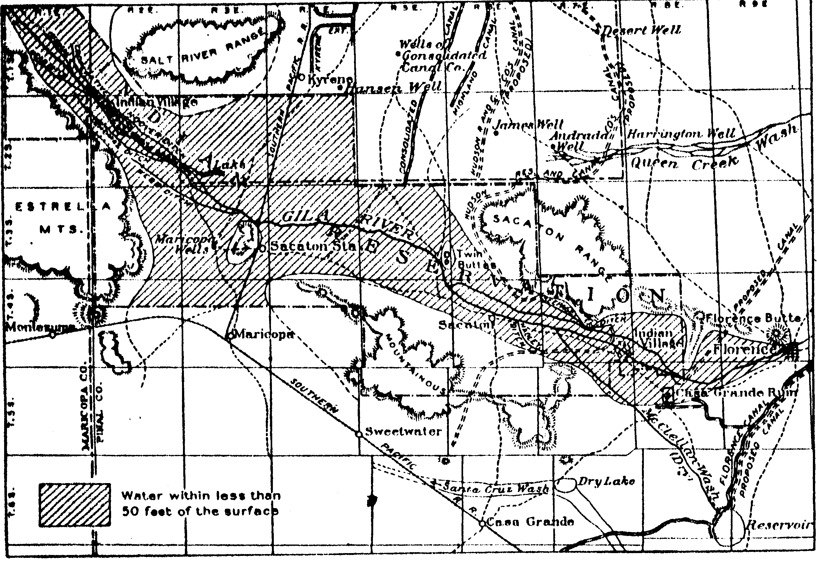
The United States Reclamation Service conducted a study of the availability of groundwater beneath the Gila River Indian Community, in 1903. This map was attached to the report and indicates that ground water was within 50 feet of the surface on much of the reservation.

Teacher Plan for “Four or Five Acres of Irrigated Land”

Objectives

Students will be able to:

- Analyze the long-term limitations of water resources and its potential impact on the Pima and Maricopa if they had accepted the pumping and land cession proposition.

- Compare and contrast the provisions of the Homestead and Desert land Acts with that of the proposed allotment scheme at Gila River.
Terms to know and understand

- Slough
- Wetlands
- Seepage
- Marsh
- Perpetual
- Ubiquitous
Critical Thinking:

- It’s 1903 and you have lived on the reservation all of your life
without water. Now you are presented with an opportunity to
receive water if you agree to move to the Santan area. Do you
agree to remove and receive water? Or do you remain where you
are and hope water is eventually brought to your land? Would
you be willing to sell half of your land if there was a promise
of water? What if you were informed the water supplied might last less than fifty years?
Activities:

- President Lincoln signed into law the Homestead Act in 1863. According to this law, American citizens were entitled to receive 160 acres of land from the government on the condition that the land was improved and a home built on it. The Desert Land Act of 1884 did the same for citizens seeking to settle in the desert, except they could receive 640 acres. Other similar laws provided for the acquisition of timber and other lands, as well. Under the proposal for supplying water to Gila River, the Indian Service proposed five-acre allotments with water, ostensibly because there was insufficient water to provide for the irrigation of 160 acres per person. Was this proposal discriminatory in that non-Indians were allowed to select far larger tracts of land? Or was it true, as Frederick Newell suggested, that Pima farmers only needed four or five acres to meet the needs of their families? And if this were true, why would non-Indians need so much more land?

- The 1903 Reclamation Service study of the underground waters of the Gila River noted that this supply of water would last anywhere from 28 to 49 years, depending on the actual volume of water under the ground. What did the “life expectancy of water” mean for the Pima and Maricopa who were nearly forced to give up half of their reservation lands in exchange for these wells?
About P-MIP

The Pima-Maricopa Irrigation Project is authorized by the Gila River Indian Community to construct all irrigation systems for the Community. When fully completed, P-MIP will provide irrigation for up to 146,330 acres of farmland. P-MIP is dedicated to three long-range goals:
- Restoring water to the Akimel O’otham and Pee Posh.
- Putting Akimel O’otham and Pee Posh rights to the use of water to beneficial use.
- Demonstrating and exercising sound management to ensure continuity of the Community’s traditional economy of agriculture.

